**SECTION ONE (4 Parts)**

Part 1A

Find an app in any industry you like. This assignment may be easier for you if you find an app that has a lot of competition and isn’t ranking well. This means navigating further on the app store results page. Download the app and use it. Note the app name and category.

I’m interested in running at the free time, so I searched some “steps count” Apps. I slim the list very down and select an App called “**Activity Fun with Speed**”. It was under the **Health & Fitness** category.

It will show you the steps and calories per day, and tell you It will tell you how long to walk, how long to run, how long driving. I'd be surprised that it was so detailed.

Part 1B

Identify what you think is an important goal for that app. For example, beyond downloads, is this website trying to get people to click on ads, buy additional products or features within the app, subscribe to an email or service in the app or on a website, or upsell within the app, etc.

Activity Fun with Speed is free for download and use, but there are many full screen ads pop up. There is an ads bar at the bottom of the screen. Finally, an arrow point to the top right corner, there is another App called “BMI“ which is a relationship App with it.

**Ads click** and **download BMI** is the most important goals for it.

Part 1C

Create a free account for App Annie and Search Man.

I created an account in “Search Man” and “App Annie”.

Part 1D:

Using a few of the app tools, perform in-depth analysis for that app. You do not need to contact the business, simply make best guesses based on what you see within the app after you’ve downloaded it.

Start with keyword research, identify the following. Identify 7-10 keywords which you think provide the best opportunity for the example site to rank for.

* Identify long-tail keyword opportunities
* Identify obvious head terms of brand and non-brand keywords
* Identify what other competitors each keyword ranks for.
* Explain why you chose the keywords you did.
* How do you feel these keywords would help the business meet the goal you discovered, starting with downloads?
* How do you feel these keywords would help draw in organic traffic to the site?
* How well do you think the business can effectively compete for this keyword?

The thinking was that finding the magical combination of low competition, high traffic words would drive heaps of organic traffic to even the worst of mobile apps.

When people search for a run app they will add the steps or speedometers as a condition, and some people were want to lose weight, so they need to know how much calories be burned in their running.

1. Goud steps count

Rank: 2

Reason: This is a Brand keyword.

Main Competition: N/A

1. run steps gps

Rank: N/A

Reason: GPS is an important condition for an app to count the steps and measure the distance.

Main Competition: S**teps pedometer & step Counter activity Tracker**

1. calories burned walking steps

Rank: N/A

Reason: people keep running need to know how many calories were burned.

Main Competition: **Footsteps - pedometer**

1. walk calorie calculator

Rank: N/A

Reason: people keep running need to know how many calories were burned.

Main Competition: **Calorie Counter: Health Fitness Pro, steps Tracker**

1. activity speedometers

Rank: 1

Reason: This is a vantage keyword.

Main Competition: N/A

1. activity run steps count

Rank: 5

Reason: When someone was running he/she how long and how many steps he/she run.

Main Competition: **Stepz: pedometer & step counter for tracking steps**

1. activity weight lose

Rank: N/A

Reason: There too many fat people want to know how much weight when they make a sport could lose the weight.

Main Competition: **Pacer - pedometer plus weight Loss and bmi tracker**

1. accurate pedometer

Rank: N/A

Reason: I installed many Apps for count the steps, but all of them show me different counts, so users should use an accurate one.

Main Competition: **Pedometer Plus - step Counter & walking Tracker**

The completion App runs keywords: Pedometer, Tracker, BMI, Weight lose, Walking distance tracker, Steps track and Calories burned etc.

Keywords and description are very important for the ASO, so with sufficient effort and enough savvy, you can create an app that will get found. All of these keywords is for the guess by user such as me. I try many different keywords for search a suitable app to track my activity.

**SECTION TWO (6 Parts)**

Part 2A

Using some of the tools, go deeper into understanding what causes that app to rank how it does.

* What other features do you see in competitive apps for this keyword that enable other apps to rank higher? For example, ratings or reviews, descriptions, or images.
* Are there patterns you notice regularly among the competitors?

Encourage ratings and feedback always be good for the optimization. But in fact, there is no review of this app.

In my research, first, the description was simple (it should be more detail). So, it should to create a compelling description; it should be targeted toward the customer base, rather than a search engine index. The description should be viewed as a call-to-action for potential customers. Describe what it does in simple and concise language, list the unique benefits it offers, and compel the reader to download it. Second, the ads were pop up frequently; it will make user angry, some other apps’ ads will pop up after you use one time, it was accepted more easily. Third, they should add some screenshots and videos at the beginning of the introduction. Fourth, there are some promotion could be hold to increase traffic off-line.

Some options for make the ASO:

* Titles and Keywords
* Ratings and Reviews
* Number of Downloads
* Focus groups
* Online surveys
* Social media feedback
* Design the perfect App icon
* Feature screen shots

All of these skills are not be used. So the rank was woeful.

Part 2B

Choose three other competitive apps for a specific keyword or group of keywords. Pick those apps that rank well consistently for keyword phrases similar to your first app.

Once you’ve selected the three apps plus your original, take screenshots of the following data charts and put in a document or slide deck (as if preparing a research and competitive audit presentation for a client):

* Visibility Score (use Search Man app)
* Download Volume and Velocity (use App Annie app)
* Ratings and Reviews (use App Annie app)

Use whatever time period and other filters you think is appropriate, as long as it’s consistent between all four (your original and the three competitors) apps.

Keyword: activity steps count

Install:

**Activity fun with speed**

Visibility score:

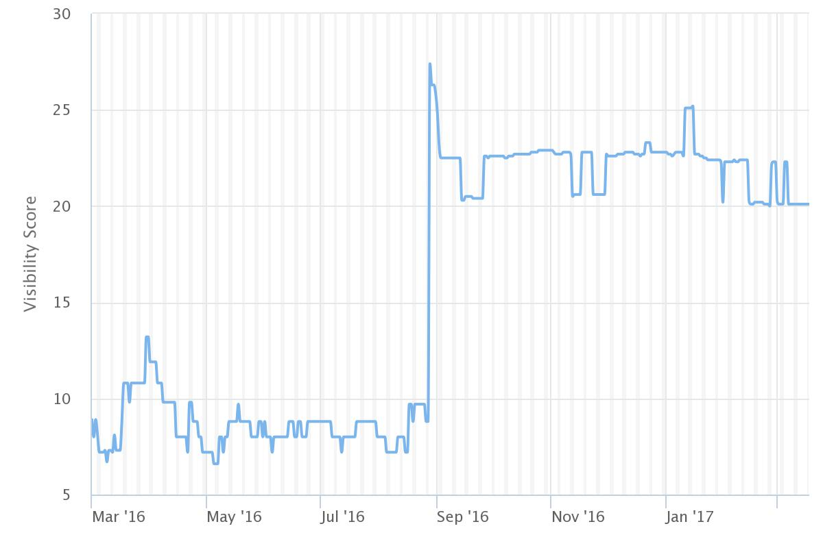

Ratings: None

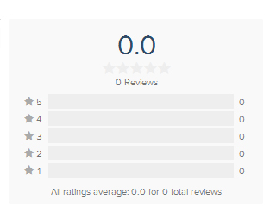

**Download Volume and Velocity**: **It is a professional account authority. I cannot get it.**

Screenshots:

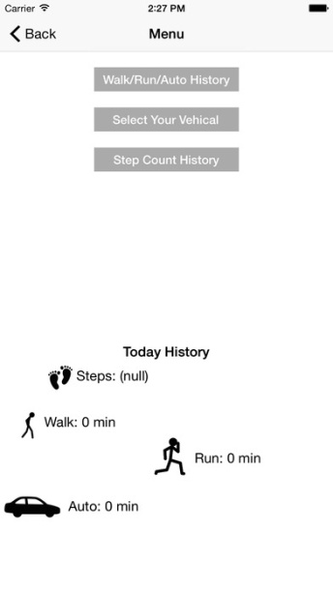

Keywords: speedometer, activity steps count etc.

**Pacer - pedometer plus weight Loss and bmi tracker**

Visibility score:

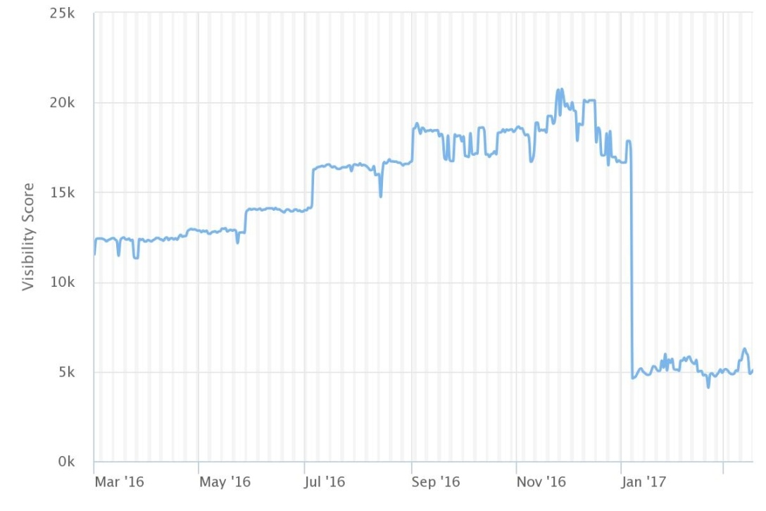

Ratings:

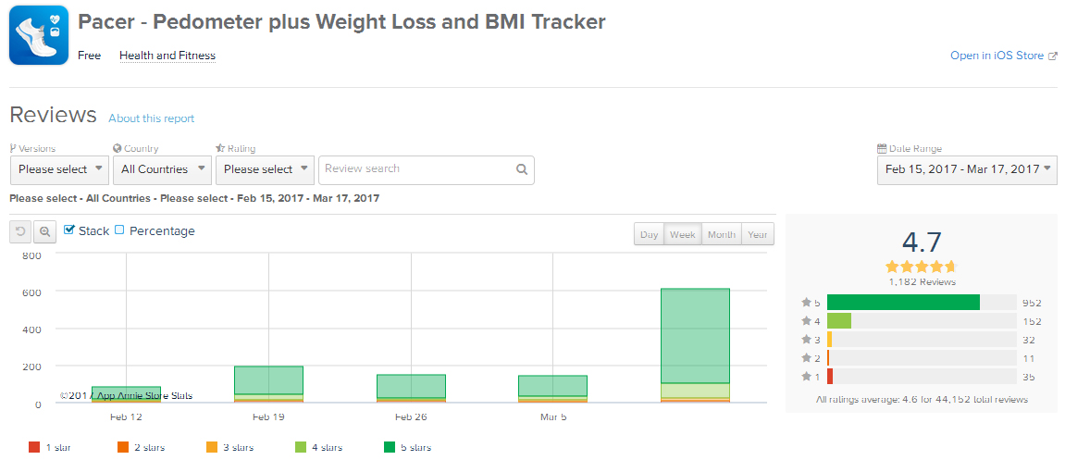

**Download Volume and Velocity**: **It is a professional account authority. I cannot get it.**

Screenshots:

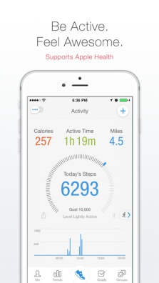

Keywords: tracker, BMI, weight lose, pedometer etc.

**Stepz: pedometer & step Counter for tracking steps**

Visibility score:

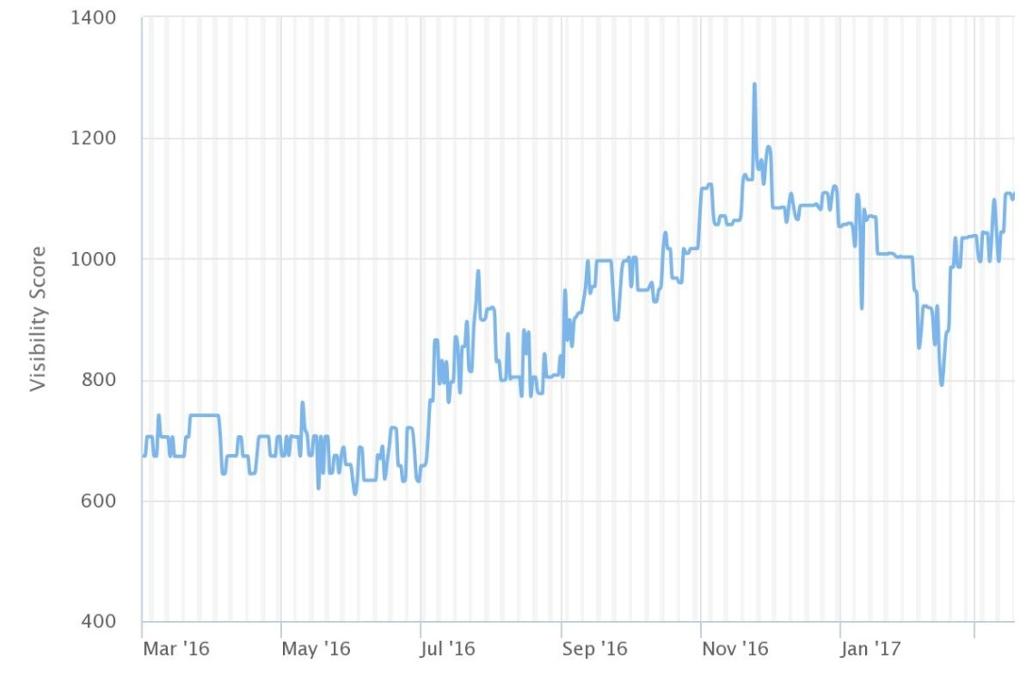

Ratings:

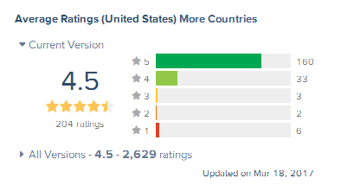

**Download Volume and Velocity**: **It is a professional account authority. I cannot get it.**

Screenshots:

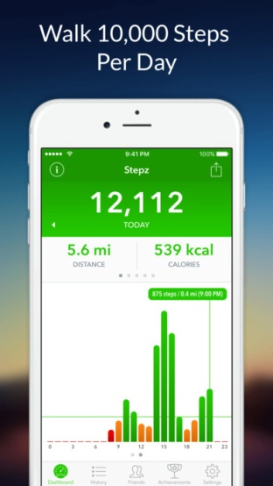

Keywords: setp counter, pedometer, tracking etc.

S**teps pedometer & step Counter activity Tracker**

Visibility score:

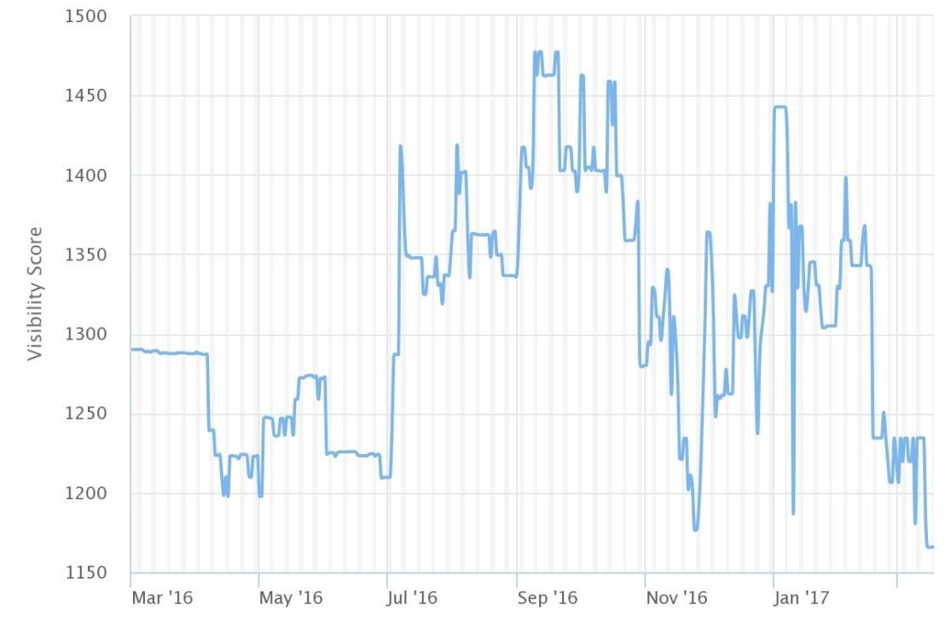

Ratings:

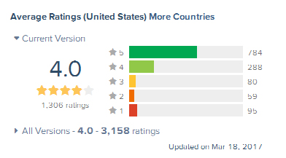

**Download Volume and Velocity**: **It is a professional account authority. I cannot get it.**

Screenshot:

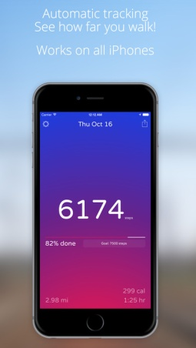

Keywords: pedometer, measure walking distance, step tracker etc.

Part 2C

Pick two other trends or data points you think worth mentioning (to a potential client, the owner of the first app you selected) and note those for all four apps as well. This could be related to Title tags, Images, Descriptions, unique features, anything else from the tools.

**Training** and **weight loss** were two popular trends in these sports track apps.

**Pacer** is good to do both of the two trends. There are several training plan for the user. And it will record the BMI such as weight, calories, BP and so on. I feel it is the most professional app in these all.

**StepZ** does not have two of these trends, but the record of the most detailed, it will show the records every day, week or month. It contains steps, distance, calories, times.

S**teps pedometer** is very simple, it can make a goal of every day. And it will show the steps you have all day, and the distance and spent time, just so so. There was not a training plan or BMI in this app.

**Activity fun** app automatically detects your activity and show the activity on the home screen like walking, running or driving. An estimated speed is displayed on home screen to make you how much speed he is walking, running, cycling and automotive. And there is no training plan and BMI in it, BMI is another app of this developer.

Part 2D

Download each app. Pick two additional features or differentiators noted by the three apps and the initial app you selected. Make note of what you like and don’t like.

**Pacer - pedometer plus weight Loss and bmi tracker:**

There are too many features compare with the **Activity Fun with Speed**, BMI, Training Plan, Social Media, and Race Notice.

I like almost all of these features, but the BMI. The BMI need an extra device to record the BP and Heart rate.

**Stepz: pedometer & step Counter for tracking steps**

There are a friends system and an achievement system in this app, it should sign up or login with the facebook account, then you can share your activity for them. The achievement system is a Goal for you, it likes a training plan but not official. The share for friends is a good idea, I like it. And the other system, I think it was too weak compare with another training plan.

**Steps pedometer & step Counter activity Tracker**

This app has the most simple UI and feature, it tell you just be absorbed in you run. It just tell you the steps and the distance time. And the advance feature is another paid app developed by the same company. I don’t like it, but the rank of it was very perfect.

Part 2E

Write a two-paragraph assessment of summary findings - of what you liked and don’t like about your app’s competitive positioning. Make note of key features or improvements you might suggest to the app owner. Point out observations that are obvious without using tools and those that can only be understood using the tools.

I like the accurate steps count and the animation icons. It can distinguish your walking, running, riding or driving and record the speed and distance, times. It’s great.

First, I hope it can connect with Google maps then it can show the path by GPS. Second, it is very useful for test the BMI, the developer make another app called BMI so I hope they could combine the two. Of cause, I don’t like too many ads, especially the popup, so if it is not necessary, please remove them.

Part 2F

Add a timeline of proposed improvements. Include specific factors you recommend they improve.

Split this into 1 week, 2 weeks, and 1 month and beyond (or even 1 week, 1 month, and 1 quarter). The actual timing doesn’t matter, but that you’ve thought through how a client might prioritize your recommendations. In the next week, you might suggest keyword or title improvements. After the first week, perhaps they’ll have bandwidth for images or description improvements. And perhaps with the next app launch, they can address some of the findings you notice in ratings and reviews or visibility score or download velocity and incorporate those into the next app release.

Week1

Add the Google map and GPS tracking.

Week2

Combine the Activity fun with speed and the BMI as a new strong App.

Week3

Add some like social and training plan feature.

Week4

Keep improving